HEALTHVISION AI: AN AI-POWERED MULTI-DISEASE
HEALTH DETECTION SYSTEM
A Project Report
Submitted in Partial Fulfilment of the Requirements for the
Award of the Degree of
Bachelor of Technology
In
Computer Science & Engineering (Artificial Intelligence)
Submitted by
GAURAV KUMAR
(Registration No. 23151144901)
NITESH KUMAR
(Registration No. 22151144040)
RUPESH KUMAR


(Registration No. 22151144010)
INDRAJEET KUMAR
(Registration No. 23151144906)
Under the Supervision of
DR. SAURABH SUMAN
Assistant Professor

Department of Computer Science & Engineering (Artificial Intelligence)
Government Engineering College, Munger
Bihar Engineering University, Patna
MAY 2026
DECLARATION AND COPYRIGHT TRANSFER

We, Gaurav Kumar, Nitesh Kumar, Rupesh Kumar, and Indrajeet Kumar, Registration No. 23151144901, 22151144040, 22151144010, and 23151144906 respectively, registered candidates of Undergraduate Programme B.Tech under Department of Computer Science & Engineering (Artificial Intelligence) of Government Engineering College, Munger declare that this is our own original work and does not contain material for which the copyright belongs to a third party and that it has not been presented and will not be presented to any other University/Institute for a similar or any other Degree award.
We further confirm that for all third-party copyright material in our thesis/dissertation (including any electronic attachments), we have "blanked out" third party material from the copies of the thesis/dissertation/book/articles etc., fully referenced the deleted materials and where possible, provided links (URL) to electronic sources of the material.
We hereby transfer exclusive copyright for this thesis to Government Engineering College, Munger. The following rights are reserved by the authors:
- The right to use, free of charge, all or part of this article in future work of their own, such as books and lectures, giving reference to the original place of publication and copyright holding.
- The right to reproduce the article or thesis for their own purpose provided the copies are not offered for sale.

Signature of the candidate: _____________________________ Date: _______________
Signature of the candidate: _____________________________ Date: _______________
Signature of the candidate: _____________________________ Date: _______________
Signature of the candidate: _____________________________ Date: _______________

COPYRIGHT NOTICE
COPYRIGHT © [2026] by Government Engineering College, Munger. All rights reserved.
No part of this publication may be reproduced, distributed, or transmitted in any form or by any means, including photocopying, recording, or other electronic or mechanical methods, without the prior written permission, except in the case of brief quotations embodied in critical scholarly reviews and certain other non-commercial uses with an acknowledgment/reference permitted by the copyright law.

DR. SAURABH SUMAN  Supervisor  Department of CSE | DR. GOVIND KUMAR JHA  Head of Department  Department of CSE | External Examiner

CERTIFICATE

This is to certify that the Project Report entitled "HEALTHVISION AI: An AI-Powered Multi-Disease Health Detection System" submitted by Gaurav Kumar (23151144901), Nitesh Kumar (22151144040), Rupesh Kumar (22151144010), and Indrajeet Kumar (23151144906) to Government Engineering College, Munger, Bihar Engineering University, Patna, in partial fulfilment for the subject Project (7th/8th Semester), Computer Science & Engineering (Artificial Intelligence) is a Bonafide record of Project carried out by them under my supervision. The contents of this Project Report, in full or part, have not been submitted to any other Institution or University for the award of any degree.

DR. SAURABH SUMAN  Supervisor  Department of CSE | DR. GOVIND KUMAR JHA  Head of Department  Department of CSE | External Examiner

ACKNOWLEDGEMENT

It is a privilege to express our deep sense of gratitude to our guide, Dr. Saurabh Suman, Assistant Professor, Department of Computer Science & Engineering, Government Engineering College, Munger, for his constant encouragement, valuable guidance, and benevolent help that was of greatest support to bring this work in its present shape.
This work is the result of inspiration, support, guidance, motivation, cooperation, and facilities extended to us at all levels. The discussions with him regarding various issues of our project have been very beneficial and gave us a new direction of thinking. All these discussions have played a vital role in the progress of our work at many critical points during our endeavor.
We are highly indebted to the Head of the Department of Computer Science & Engineering (Artificial Intelligence), Government Engineering College, Munger, for providing us with all necessary facilities and guidance.
We are thankful to our faculty members for their valuable lectures in Machine Learning, Deep Learning, Computer Vision, and Web Technologies, which helped us in designing and implementing this project. We would also like to acknowledge everyone who, from behind the scenes, contributed their ideas and energies.
We would also like to acknowledge the open-source community, the creators of TensorFlow, Keras, Flask, OpenCV, and other tools that made this project possible.
Finally, we are grateful to our family and friends for their unwavering support and encouragement throughout this journey.

GAURAV KUMAR (23151144901)
NITESH KUMAR (22151144040)
RUPESH KUMAR (22151144010)
INDRAJEET KUMAR (23151144906)

ABSTRACT

HealthVision AI is an intelligent, AI-powered web application that leverages Deep Learning and Computer Vision techniques to detect multiple health conditions from medical images in a non-invasive manner. The system provides three specialized detection modules: (i) Jaundice/Eye Detection — analyzes the sclera (white part of the eye) for yellow discoloration indicative of elevated bilirubin levels; (ii) Face/Skin Disease Detection — classifies facial skin conditions into five categories: Acne, Eczema, Herpes, Panu (Tinea Versicolor), and Rosacea; and (iii) Nail Disease Detection — identifies nail health conditions including Healthy, Onychomycosis (Fungal Infection), and Psoriasis.
The application is built using Flask (Python web framework), TensorFlow/Keras for deep learning model inference, and OpenCV for image preprocessing. Transfer learning architectures — MobileNetV2 and EfficientNetB0 — pre-trained on ImageNet are fine-tuned on curated medical image datasets using a two-stage training strategy. The image preprocessing pipeline applies Bilateral Filtering for denoising and CLAHE (Contrast Limited Adaptive Histogram Equalization) for contrast normalization before inference.
The system features a modern, responsive web interface supporting both image upload and live camera capture using WebRTC, with an ROI guide overlay for precise capture. Prediction results include confidence scores, top-3 predictions, severity levels, and a comprehensive disease information database. An AI Health Assistant provides structured report explanation, guided Q&A, precautions, diet guidance, hospital finder, and appointment booking support.
Model validation accuracies achieved are: Jaundice Detection — 90.62%, Face/Skin Disease Detection — 72.15%, and Nail Disease Detection — 85.71%. The application is deployed on Render cloud platform and is accessible at https://healthvision-ai-1enh.onrender.com.

Keywords: Deep Learning, Convolutional Neural Networks, Transfer Learning, MobileNetV2, EfficientNetB0, Medical Image Classification, Flask, TensorFlow, OpenCV, Jaundice Detection, Skin Disease, Nail Disease, Healthcare AI, Computer Vision
TABLE OF CONTENTS

Abstract ................................................................................................................................. 06
CHAPTER 1: Introduction ................................................................................................... 11
1.1 Background ................................................................................................................... 11
1.2 Motivation .................................................................................................................... 11
1.3 Project Overview .......................................................................................................... 12
1.4 Special Technical Terms and Concepts ........................................................................ 12

CHAPTER 2: Background & Literature Review .................................................................. 14
2.1 Deep Learning in Medical Imaging .............................................................................. 14
2.2 Transfer Learning for Medical Classification ............................................................... 14
2.3 Jaundice Detection via Sclera Analysis ........................................................................ 15
2.4 Skin Disease Classification ........................................................................................... 15
2.5 Nail Disease Detection .................................................................................................. 15
2.6 Comparison of Existing Approaches ............................................................................ 16
2.7 Research Gaps ............................................................................................................... 16

CHAPTER 3: Problem Definition ........................................................................................ 17
3.1 Primary Problem ........................................................................................................... 17
3.2 Stakeholders Affected ................................................................................................... 18
3.3 Limitations of Current Solutions .................................................................................. 18

CHAPTER 4: Proposed Solution .......................................................................................... 19
4.1 Project Objectives ......................................................................................................... 19
4.2 System Architecture ..................................................................................................... 19
4.3 Detection Modules ....................................................................................................... 20
4.4 Dataset Description ...................................................................................................... 23
4.5 Methodology & Algorithms ......................................................................................... 24
4.6 Image Preprocessing Pipeline ...................................................................................... 24
4.7 Technology Stack ......................................................................................................... 25
4.8 System Design (UML) ................................................................................................. 26
4.9 Implementation Details ................................................................................................ 27
4.10 Web Application Screenshots .................................................................................... 28

CHAPTER 5: Discussion of Results .................................................................................... 32
5.1 Training Results & Accuracy ....................................................................................... 32
5.2 Testing .......................................................................................................................... 33
5.3 Advantages & Limitations ............................................................................................ 34

CHAPTER 6: Conclusion and Future Work ........................................................................ 35
6.1 Conclusion .................................................................................................................... 35
6.2 Future Scope ................................................................................................................. 36

References ............................................................................................................................. 37
LIST OF FIGURES

Figure 1.1: HealthVision AI Web Application Hero Page ................................................... 11
Figure 4.1: System Workflow Diagram ................................................................................ 20
Figure 4.2: Application Flowchart ........................................................................................ 27
Figure 4.3: MobileNetV2 Architecture for Jaundice Detection ………………………….... 21
Figure 4.4: EfficientNetB0 Architecture for Face/Skin Detection …………..……………. 22
Figure 4.5: MobileNetV2 Architecture for Nail Disease Detection ……………………….. 23
Figure 4.6: Image Enhancement Pipeline ............................................................................. 26
Figure 4.7: Use Case Diagram .............................................................................................. 26
Figure 4.8: Sequence Diagram ............................................................................................. 26
Figure 4.9: Health Screening Tool Web Interface ................................................................ 28
Figure 4.10: Core Capabilities / Features Page ..................................................................... 28
Figure 4.11: Eye/Jaundice Detection Result ......................................................................... 29
Figure 4.12: Face/Skin Disease Detection Result ................................................................. 29
Figure 4.13: Nail Disease Detection Result .......................................................................... 30
Figure 4.14: How It Works Pipeline Page ............................................................................ 30
Figure 4.15: Application Flowchart Web Page .................................................................... 27
Figure 4.16: Technologies & Tools Page ............................................................................. 31
Figure 4.17: AI Clinical Assistant Page ............................................................................... 31
Figure 4.18: Project Team .................................................................................................... 31

LIST OF TABLES

Table 4.1: Feature Description ............................................................................................. 19
Table 4.2: Jaundice Detection Module Details .................................................................... 21
Table 4.3: Face/Skin Detection Module Details .................................................................. 22
Table 4.4: Nail Disease Detection Module Details .............................................................. 22
Table 4.5: Dataset Summary ................................................................................................ 23
Table 4.6: Backend Technologies ........................................................................................ 25
Table 4.7: Frontend Technologies ........................................................................................ 25
Table 4.8: Unit Test Results ................................................................................................. 33
Table 4.9: Integration Test Results ....................................................................................... 33
Table 5.1: Model Training Results ....................................................................................... 32

ABBREVIATIONS

Abbreviation | Full Form
AI | Artificial Intelligence
CNN | Convolutional Neural Network
DL | Deep Learning
ML | Machine Learning
CV | Computer Vision
CLAHE | Contrast Limited Adaptive Histogram Equalization
ROI | Region of Interest
API | Application Programming Interface
REST | Representational State Transfer
JSON | JavaScript Object Notation
AJAX | Asynchronous JavaScript and XML
WebRTC | Web Real-Time Communication
WSGI | Web Server Gateway Interface
BEU | Bihar Engineering University
GEC | Government Engineering College
CSE | Computer Science & Engineering
HDF5 | Hierarchical Data Format version 5
HSV | Hue-Saturation-Value (color model)
LAB | L*a*b* (CIE color space)
BGR | Blue-Green-Red (OpenCV color format)
RGB | Red-Green-Blue (standard color format)

CHAPTER 1

INTRODUCTION

1.1 Background
Healthcare accessibility remains a significant challenge in many parts of the world, particularly in rural and underserved regions of India. Early detection of diseases is crucial for effective treatment and better health outcomes, but access to qualified medical professionals, especially dermatologists and ophthalmologists, is often severely limited. With rapid advancements in Artificial Intelligence (AI) and Deep Learning, it is now possible to develop automated disease detection systems that can provide preliminary health assessments using only a photograph.
Convolutional Neural Networks (CNNs) and Transfer Learning have revolutionized medical image analysis over the past decade. Research has demonstrated that AI models can achieve expert-level performance in detecting conditions like skin cancer, diabetic retinopathy, and various dermatological diseases. The democratization of powerful pre-trained models such as MobileNetV2 and EfficientNetB0 through frameworks like TensorFlow and Keras has made it feasible to develop high-accuracy medical image classifiers even with limited domain-specific training data.
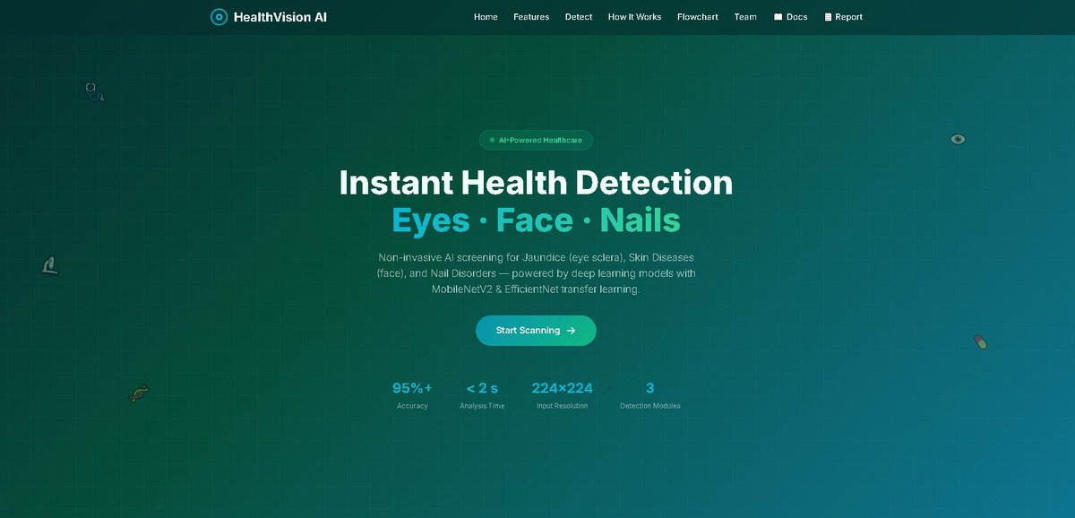
Figure 1.1: HealthVision AI Web Application Hero Page

1.2 Motivation
Skin diseases, jaundice, and nail conditions are among the most common health issues worldwide. Visual inspection is the primary diagnostic method for these conditions, making them ideal candidates for AI-based image analysis. In India, millions of patients in rural and semi-urban areas lack timely access to specialist care. Jaundice detection traditionally requires blood tests to measure bilirubin levels — an invasive and costly procedure. Many skin conditions are routinely misdiagnosed or left untreated due to lack of dermatological expertise.
This project is motivated by the urgent need to bridge the gap between patients and early diagnosis by providing an accessible, non-invasive, AI-powered screening tool that works on any device with a camera and internet connection. HealthVision AI aims to empower individuals with instant preliminary health assessments, encouraging timely medical consultation.

1.3 Project Overview
HealthVision AI is a comprehensive health detection platform that combines three distinct medical image analysis modules into a single unified web application. Users can upload images or use their device camera to capture photographs of eyes, face/skin, or nails, which are then analyzed by trained deep learning models to provide instant health assessments along with detailed medical information.
The system is built using Python (Flask) as the backend, TensorFlow/Keras for deep learning inference, and OpenCV for image preprocessing. The frontend is a responsive single-page application built with HTML5, CSS3, and JavaScript with WebRTC camera integration. The application is deployed on Render cloud platform.
GitHub Repository: https://github.com/gauravssah/HealthVision-AI
Live Demo: https://healthvision-ai-1enh.onrender.com

1.4 Special Technical Terms and Concepts Relevant to the Project
Transfer Learning
Transfer learning is a machine learning technique where a model trained on one large-scale task (ImageNet classification with 1.4 million images and 1000 classes) is adapted for a different but related task with limited data. The pre-trained model's weights serve as a strong feature initialization, dramatically reducing training time and improving accuracy.
MobileNetV2
MobileNetV2 is a lightweight CNN architecture designed for mobile and embedded vision applications. It uses inverted residuals and linear bottlenecks to achieve high accuracy with significantly fewer parameters (~3.4 million) and computational cost compared to standard CNNs. In this project, MobileNetV2 is used for Jaundice and Nail Disease detection.
EfficientNetB0
EfficientNetB0 is a CNN architecture that uses a compound scaling method to uniformly scale network width, depth, and resolution using a fixed set of coefficients. This achieves state-of-the-art accuracy with fewer parameters than competing models. In this project, EfficientNetB0 is used for Face/Skin Disease detection.
OpenCV Haar Cascade Classifiers
Haar Cascade classifiers are classical computer vision algorithms for object detection. They use Haar-like features and a cascade of classifiers to detect objects in images efficiently. In HealthVision AI, Haar cascades (haarcascade_frontalface_default.xml and haarcascade_eye.xml) are used for face and eye region detection before jaundice analysis.
CLAHE (Contrast Limited Adaptive Histogram Equalization)
CLAHE is an advanced image enhancement algorithm that improves local contrast in images while preventing over-amplification of noise. Unlike standard histogram equalization, CLAHE operates on small tiles of the image and uses a clip limit to reduce noise amplification, making it ideal for medical image preprocessing under varying lighting conditions.
Bilateral Filter
A bilateral filter is an edge-preserving image denoising technique that smooths images while preserving edges. Unlike Gaussian blur, it considers both spatial proximity and pixel intensity similarity, making it ideal for cleaning up camera noise in medical images without blurring diagnostically important features such as skin texture and nail ridges.

CHAPTER 2

BACKGROUND & LITERATURE REVIEW

2.1 Deep Learning in Medical Imaging
Convolutional Neural Networks (CNNs) have revolutionized medical image analysis over the past decade. A landmark study by Esteva et al. (2017) demonstrated that a CNN trained on 129,450 clinical images achieved dermatologist-level performance in classifying skin cancer, with accuracy comparable to 21 board-certified dermatologists. This work established the feasibility of AI-powered dermatological diagnosis.
Gulshan et al. (2016) developed a deep learning algorithm for diabetic retinopathy detection from retinal fundus photographs, achieving high sensitivity and specificity comparable to ophthalmologists. These foundational works validated the potential of CNNs for automated medical image analysis and inspired numerous subsequent studies in healthcare AI.

2.2 Transfer Learning for Medical Classification
Transfer learning has proven highly effective for medical image classification tasks where labeled data is limited. Pre-trained models on large-scale datasets such as ImageNet provide rich feature representations that transfer well to medical imaging domains. Fine-tuning the top layers of these models on domain-specific datasets consistently outperforms training from scratch, especially when training data is scarce.
Rajpurkar et al. (2017) demonstrated that a 121-layer DenseNet trained with transfer learning on chest X-rays exceeded radiologist performance on pneumonia detection. Similar approaches have been applied to skin lesion classification (HAM10000 dataset), diabetic retinopathy grading, and pathology slide analysis, establishing transfer learning as the gold standard for medical image classification with limited data.
MobileNetV2 (Sandler et al., 2018) and EfficientNetB0 (Tan & Le, 2019) are particularly well-suited for resource-constrained deployments while maintaining competitive accuracy. Their lightweight architectures enable deployment on cloud platforms with limited computational resources.

2.3 Jaundice Detection via Sclera Analysis
Several studies have explored non-invasive jaundice detection by analyzing the yellow discoloration of the sclera (eye whites) caused by elevated bilirubin levels. Colour space analysis in HSV and CIE LAB colour spaces is particularly effective for detecting yellowness, as the L and B channels in LAB space are sensitive to yellow-blue colour shifts.
Jaiswal et al. (2018) proposed a smartphone-based jaundice screening system using sclera colour analysis with an accuracy of 92% on a clinical dataset. OpenCV Haar cascade classifiers provide a robust and efficient method for eye region localization, enabling accurate sclera extraction for subsequent colour analysis and deep learning classification.

2.4 Skin Disease Classification
Automated skin disease classification using CNNs has been extensively researched. The ISIC (International Skin Imaging Collaboration) challenge and the HAM10000 dataset have driven significant advances in dermatological AI. Models trained on these datasets have achieved accuracy exceeding 80% on multi-class skin lesion classification.
For common facial skin conditions (Acne, Eczema, Rosacea, Herpes, Tinea Versicolor), specialized datasets have been collected from dermatological clinics and online medical databases. EfficientNetB0 with ImageNet pre-training and custom classification heads has shown consistently strong performance across dermatological classification benchmarks due to its compound scaling approach.

2.5 Nail Disease Detection
Nail disorders are important diagnostic indicators for systemic diseases. Onychomycosis (fungal nail infection) is one of the most common nail conditions, affecting approximately 10% of the global population. Nail psoriasis affects 80–90% of psoriasis patients and can be an indicator of psoriatic arthritis.
AI-based nail analysis is an emerging field. MobileNetV2, being lightweight and efficient, has been successfully applied to nail condition classification in embedded and mobile contexts. The visual distinctiveness of nail conditions (discoloration, texture changes, deformation) makes them suitable for image-based classification.

2.6 Comparison of Existing Approaches
Approach | Task | Model | Limitation
Blood Test (Traditional) | Jaundice | N/A | Invasive, requires lab
Dermatoscopy | Skin Disease | Expert Visual | Requires specialist
HAM10000 + EfficientNet | Skin Lesion | EfficientNetB0 | Limited to specific lesions
Sclera Color Analysis | Jaundice | Color Space | No disease info
HealthVision AI (Ours) | Multi-disease | MobileNetV2 + EfficientNet | Multi-module, web-based, complete

2.7 Research Gaps
Despite significant advances, the following gaps exist in current approaches:
- No unified platform integrates multiple body-part disease detection (eyes, face, nails) into a single accessible web application.
- Existing jaundice detection systems lack an end-to-end pipeline from sclera extraction to disease reporting.
- Most research systems are academic prototypes without cloud deployment or user-friendly interfaces.
- No existing system integrates AI-powered post-prediction support including hospital finder and appointment booking.
- Accessible, non-invasive screening tools for rural/underserved populations in India are largely absent.

CHAPTER 3

PROBLEM DEFINITION

3.1 Primary Problem
Many common health conditions — including jaundice, skin diseases, and nail disorders — require visual inspection for initial diagnosis. The primary problem addressed by HealthVision AI is the lack of accessible, non-invasive, and instant preliminary screening tools for these conditions, particularly in areas with limited healthcare infrastructure.
Specifically:
- Jaundice detection traditionally requires blood tests to measure serum bilirubin levels, which are invasive, time-consuming, and costly — especially in rural settings.
- Common skin conditions (Acne, Eczema, Herpes, Panu, Rosacea) require dermatological expertise for accurate diagnosis. Many patients in India wait weeks or months for a specialist appointment.
- Nail abnormalities can indicate serious systemic conditions such as liver disease, anemia, autoimmune disorders, and fungal infections. Early visual detection could prompt timely medical intervention.
- Manual visual inspection can be subjective and prone to human error, especially without specialist training.

3.2 Why is This Problem Important?
The World Health Organization estimates that over 1.7 billion people lack access to essential health services. In India, the doctor-to-patient ratio in rural areas is far below the WHO recommended standard of 1:1000. Skin diseases affect approximately 34% of the Indian population at any given time, and jaundice has a significant prevalence due to hepatitis, malaria, and other common infectious diseases.
Delayed diagnosis leads to disease progression, increased treatment costs, and worse health outcomes. An AI-powered preliminary screening tool accessible via a smartphone or computer can bridge the gap between first noticing symptoms and seeking professional medical care, enabling earlier intervention and better outcomes.

3.3 Stakeholders Affected
- Patients in rural and semi-urban areas with limited access to specialist care.
- Primary health workers and community health volunteers who need quick screening tools.
- Medical students and practitioners who can use the tool for preliminary assessment and education.
- Healthcare system administrators seeking to triage patients before specialist consultation.

3.4 Limitations of Current Solutions
- Blood-based jaundice tests are invasive, require laboratory infrastructure, and produce results with a delay.
- Existing AI-based skin disease classifiers are either research prototypes not accessible to the public, or are limited to a narrow set of conditions.
- No single platform combines eye, face, and nail disease detection with a user-friendly interface and post-prediction AI assistance.
- Most systems lack deployment-level stability features (e.g., graceful handling of low-quality images, cloud deployment, mobile responsiveness).
- Privacy concerns with cloud-based medical image systems: existing solutions often store or transmit patient images.

CHAPTER 4

PROPOSED SOLUTION

4.1 Project Objectives
The key objectives of HealthVision AI are:
- Develop a multi-module AI platform capable of analyzing eye, face, and nail images for disease detection using deep learning.
- Implement Transfer Learning with MobileNetV2 and EfficientNetB0 for high-accuracy classification with limited medical training data.
- Build an intelligent eye detection pipeline using OpenCV Haar cascades with dual-strategy detection and fallback mechanisms.
- Create a responsive web interface supporting both image upload and real-time camera capture with ROI guide overlay.
- Ensure user privacy by processing all data locally on the server — no images stored or transmitted to third-party services.
- Provide detailed disease information alongside predictions for educational and screening purposes.
- Integrate an AI Health Assistant for post-screening guidance: report explanation, precautions, hospital finder, and appointment booking.
- Deploy the application on a cloud platform for universal accessibility.

4.2 System Architecture
HealthVision AI follows a client-server architecture with a Flask backend serving three independent deep learning models. The system is designed for end-to-end prediction from image capture to clinical result rendering.
Key architectural components:
- Frontend: Responsive single-page application (HTML5/CSS3/JavaScript) with WebRTC camera and Canvas API ROI overlay.
- Backend: Flask REST API server for model loading, image preprocessing, and prediction endpoints.
- AI Models: Three TensorFlow/Keras models (.h5 format) for Jaundice, Skin, and Nail detection.
- Image Pipeline: OpenCV bilateral filter + CLAHE enhancement, Haar cascade detection, model-specific normalization.
- Disease Database: Built-in Python dictionary of 25+ conditions with severity, descriptions, causes, symptoms, and recommendations.
- AI Assistant: Context-aware chatbot consuming scan payload for guided Q&A, hospital finder, and booking support.

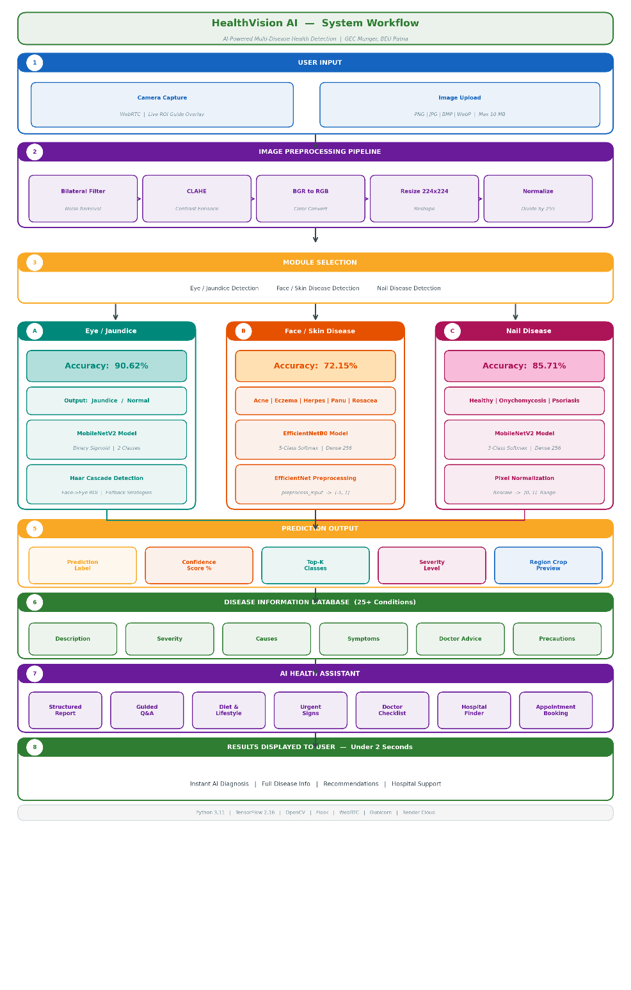
Figure 4.1: HealthVision AI Complete System Workflow Diagram

4.3 Detection Modules
Module 1: Eye / Jaundice Detection
The Jaundice Detection module analyzes the sclera (white part of the eye) for yellow discoloration caused by elevated bilirubin levels. This provides a non-invasive alternative to blood-based bilirubin tests.
Property | Details
Model File | jaundice_model.h5
Architecture | MobileNetV2 → GlobalAvgPool2D → Dense(128, ReLU) → Dropout(0.4) → Dense(1, Sigmoid)
Task | Binary Classification — Jaundice vs Normal
Input Size | 224 × 224 × 3 RGB
Preprocessing | Bilateral Filter + CLAHE → Haar Cascade Eye Detection → Crop + 35% Padding → Resize → Normalize [0,1]
Detection Strategy | Face→Eye ROI (primary) → Direct Eye (fallback) → Full Image (last resort)
Validation Accuracy | 90.62%

Table 4.2: Jaundice Detection Module Details
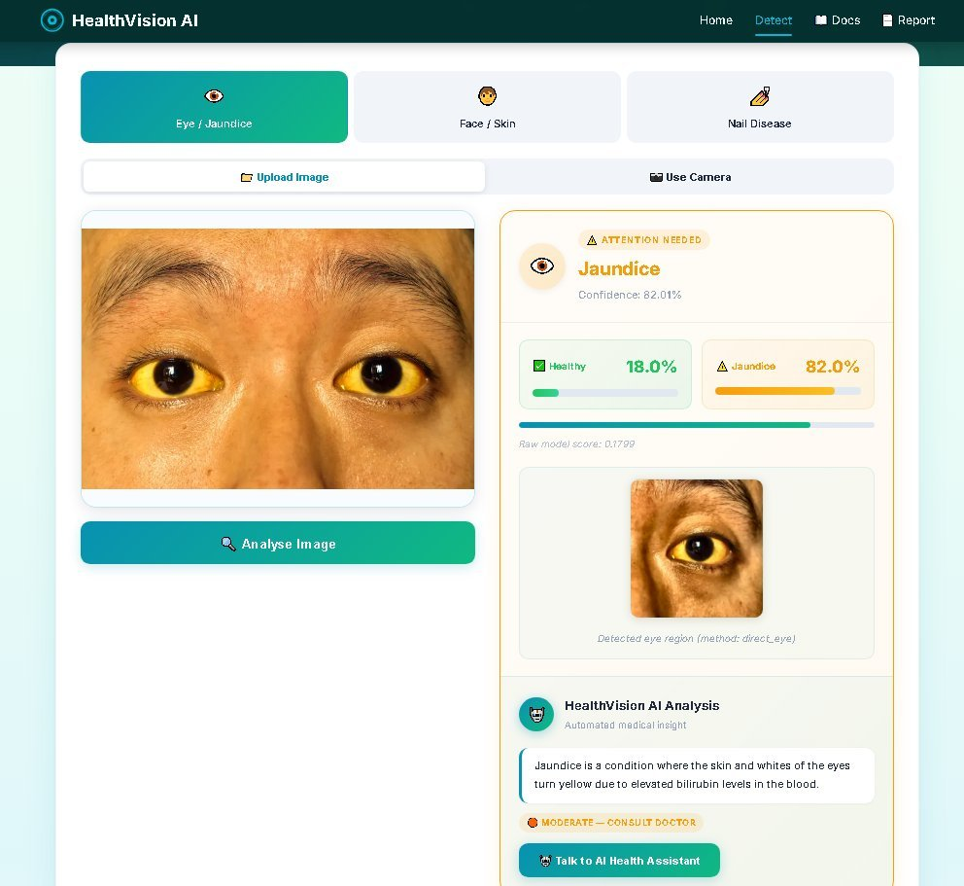
Figure 4.3 (partial): Jaundice Detection Result Screen
Module 2: Face / Skin Disease Detection
The Face/Skin Disease Detection module classifies facial skin conditions into five categories using EfficientNetB0 transfer learning.
Property | Details
Model File | face_model.h5
Architecture | EfficientNetB0 → GlobalAvgPool2D → BatchNorm → Dense(256, ReLU) → Dropout(0.5) → Dense(5, Softmax)
Task | 5-Class Classification — Acne, Eczema, Herpes, Panu, Rosacea
Input Size | 224 × 224 × 3 RGB
Preprocessing | Bilateral Filter + CLAHE → EfficientNet preprocess_input (scales to [-1, 1])
Output | Top-3 predictions with confidence scores
Validation Accuracy | 72.15%

Table 4.3: Face/Skin Detection Module Details
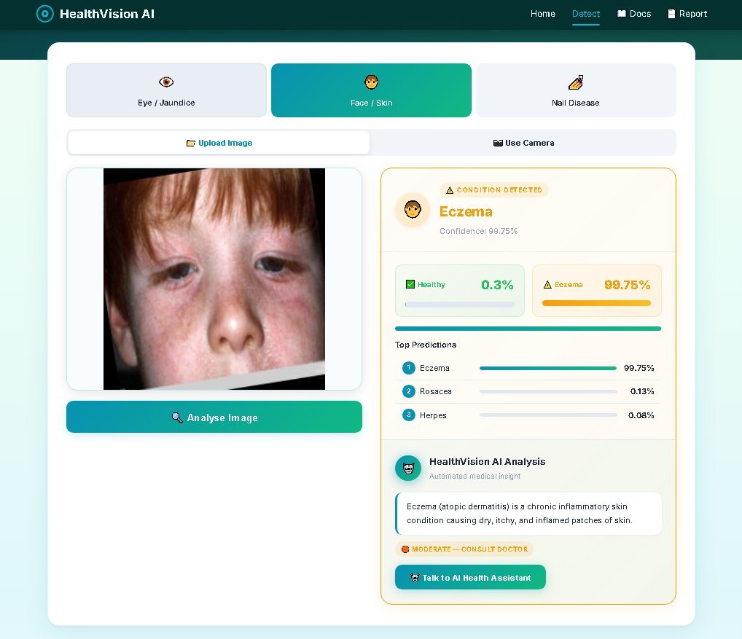
Figure 4.4 (partial): Face/Skin Disease Detection Result Screen
Module 3: Nail Disease Detection
The Nail Disease Detection module identifies nail health conditions from nail photographs using MobileNetV2.
Property | Details
Model File | nail_model.h5
Architecture | MobileNetV2 → GlobalAvgPool2D → Dense(256, ReLU) → Dropout(0.5) → Dense(3, Softmax)
Task | 3-Class Classification — Healthy, Onychomycosis, Psoriasis
Input Size | 224 × 224 × 3 RGB
Preprocessing | Bilateral Filter + CLAHE → BGR to RGB → Resize → Normalize [0,1]
Output | Top-3 predictions with confidence scores and disease info
Validation Accuracy | 85.71%

Table 4.4: Nail Disease Detection Module Details
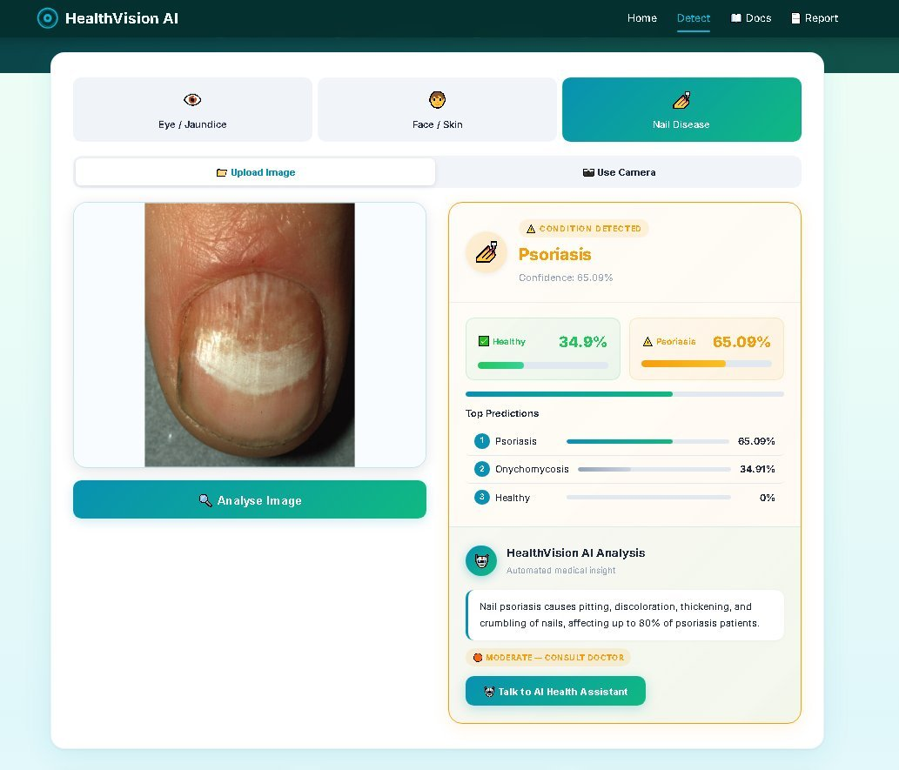
Figure 4.5 (partial): Nail Disease Detection Result Screen

4.4 Dataset Description
Each detection module is trained on a curated medical image dataset. All datasets are preprocessed to 224×224 RGB format with appropriate normalization. Data sources:
- Jaundice Eye Dataset: GTS AI Jaundiced/Normal Eyes Dataset (https://gts.ai/dataset-download/jaundiced-normal-eyes-dataset/)
- Face Skin Disease Dataset: GTS AI Facial Skin Diseases Dataset (https://gts.ai/dataset-download/facial-skin-diseases-dataset/)
- Nail Disease Dataset: Kaggle — Nail Disease Image Classification Dataset by Joseph Rasanjana (https://www.kaggle.com/datasets/josephrasanjana/nail-disease-image-classification-dataset)
Dataset | Classes | Train Images | Val Images | Split | Preprocessing
Jaundice Eye | Jaundice, Normal | 136 | 32 | 80/20 | Rescale ÷255
Face Skin Disease | Acne, Eczema, Herpes, Panu, Rosacea | 1,196 | 298 | 80/20 | EfficientNet preprocess_input
Nail Disease | Healthy, Onychomycosis, Psoriasis | 933 | 231 | 80/20 | Rescale ÷255

Table 4.5: Dataset Summary
Data Augmentation (Training): Rotation (20°), Width/Height Shift (15–20%), Zoom (20%), Horizontal Flip, Brightness Range [0.7–1.3], Shear (10%), Fill Mode: Nearest.

4.5 Methodology & Algorithms
Deep Learning Approach
All three classification tasks use Convolutional Neural Networks with Transfer Learning. The two-stage training strategy is:
Stage 1 — Feature Extraction (Base Frozen): Pre-trained base model layers are frozen. Only the custom classification head is trained for 15 epochs with learning rate 1e-3, Adam optimizer, batch size 16.
Stage 2 — Fine-Tuning (Partial Unfreeze): Top 40 layers of the base model are unfrozen and trained for 25 epochs with learning rate 1e-5. Callbacks: EarlyStopping (patience=5), ReduceLROnPlateau (patience=3, factor=0.3), ModelCheckpoint (save_best_only=True).
Key Algorithms
- Convolutional Neural Networks (CNN): Feature extraction from images using convolutional, pooling, and dense layers.
- Transfer Learning: Fine-tuning of ImageNet pre-trained MobileNetV2 and EfficientNetB0 models on medical datasets.
- Haar Cascade Classifier: Classical computer vision for face and eye region detection in the jaundice pipeline.
- CLAHE: Adaptive contrast enhancement on the L channel of CIE LAB color space (clipLimit=2.0, tileGrid=8×8).
- Bilateral Filtering: Edge-preserving noise reduction (d=5, sigmaColor=50, sigmaSpace=50) before model inference.
- Color Space Analysis (HSV, LAB): Used in fallback demo-mode jaundice detection via sclera yellowness analysis.

4.6 Image Preprocessing Pipeline
Every uploaded image passes through a standardized enhancement pipeline before model inference:
Step 1 — Bilateral Denoising: cv2.bilateralFilter(image, d=5, sigmaColor=50, sigmaSpace=50). Removes noise while preserving edges critical for diagnostic features.
Step 2 — CLAHE Contrast Normalization: Applied on the L channel of CIE LAB color space (clipLimit=2.0, tileGridSize=8×8). Normalizes contrast across varying lighting conditions.
Step 3 — Module-Specific Processing: (a) Eye: Haar cascade face→eye detection, crop + 35% padding, BGR→RGB, resize to 224×224, divide by 255. (b) Face: Resize to 224×224, BGR→RGB, EfficientNet preprocess_input. (c) Nail: BGR→RGB, resize to 224×224, divide by 255.

4.7 Technology Stack
Backend Technologies
Technology | Version | Purpose
Python | 3.11 | Primary programming language
TensorFlow / Keras | 2.16.2 | Deep learning framework for model training and inference
Flask | Latest | Lightweight web framework and REST API server
Flask-CORS | Latest | Cross-Origin Resource Sharing support
OpenCV | Latest | Computer vision — Haar cascades, image processing
NumPy | Latest | Numerical computation and array operations
Pillow (PIL) | Latest | Image format handling and manipulation
Gunicorn | Latest | Production WSGI HTTP server for Render deployment

Table 4.6: Backend Technologies
Frontend Technologies
Technology | Purpose
HTML5 | Page structure and semantic markup
CSS3 | Responsive styling, CSS Grid/Flexbox, animations
JavaScript (ES6+) | Client-side logic, AJAX/Fetch API, dynamic UI rendering
WebRTC (getUserMedia) | Real-time camera access for live capture
Canvas API | ROI guide overlay drawing on live camera feed
Google Fonts (Inter) | Typography for modern, readable UI

Table 4.7: Frontend Technologies
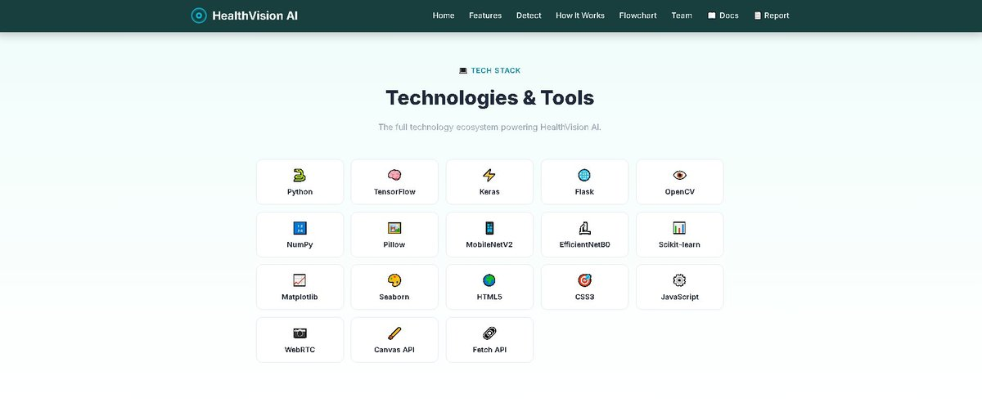
Figure 4.6 (partial): Technologies & Tools used in HealthVision AI

4.8 System Design (UML Diagrams)
4.8.1 Use Case Diagram
The use case diagram illustrates the interactions between the User (actor) and the HealthVision AI system. Key use cases include:
- Upload Image / Capture from Camera
- Select Detection Module (Eye/Jaundice, Face/Skin, Nail Disease)
- View Detection Results (Prediction, Confidence, Severity)
- View Disease Information & Recommendations
- Interact with AI Health Assistant
- Find Nearby Hospitals and Book Appointment
- View Documentation and Project Report
4.8.2 Sequence Diagram (Detection Flow)
The detection sequence follows these steps:
- User selects a detection module and uploads/captures an image via the browser.
- Browser sends HTTP POST request to the appropriate Flask endpoint (/predict/eye, /predict/face, or /predict/nail) with the image file.
- Flask backend receives the image bytes and decodes them using cv2.imdecode.
- Image Enhancement Pipeline: Bilateral Filter → CLAHE → Module-specific preprocessing.
- TensorFlow model performs inference: model.predict(preprocessed_image).
- Backend constructs JSON response with prediction, confidence, top-K, and disease_info.
- Frontend JavaScript receives JSON and dynamically renders the result card.
- User can click "Talk to AI Health Assistant" for post-prediction Q&A support.
4.8.3 Application Flowchart
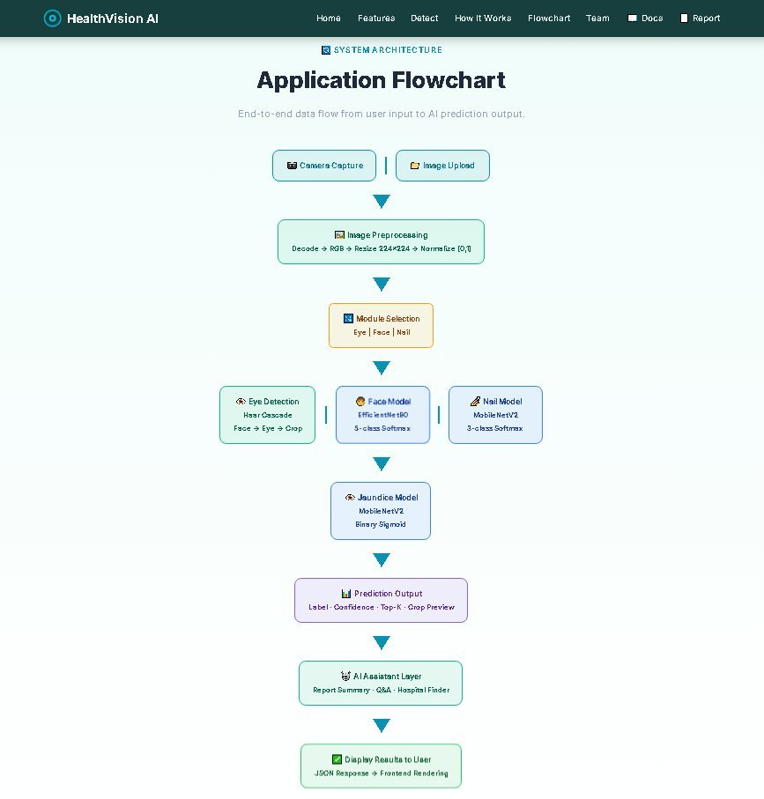
Figure 4.7: Application Flowchart — End-to-End Data Flow

4.9 Implementation Details
Key Code Snippets
Model Loading with TensorFlow Compatibility Patch:
import tensorflow as tf from tensorflow.keras.layers import DepthwiseConv2D as _Orig class PatchedDWConv(_Orig): def __init__(self, *args, **kwargs): kwargs.pop("groups", None) super().__init__(*args, **kwargs) CUSTOM_OBJECTS = {"DepthwiseConv2D": PatchedDWConv} model = tf.keras.models.load_model("model.h5", custom_objects=CUSTOM_OBJECTS)
Image Enhancement Function:
def enhance_image(image): denoised = cv2.bilateralFilter(image, d=5, sigmaColor=50, sigmaSpace=50) lab = cv2.cvtColor(denoised, cv2.COLOR_BGR2LAB) clahe = cv2.createCLAHE(clipLimit=2.0, tileGridSize=(8, 8)) lab[:, :, 0] = clahe.apply(lab[:, :, 0]) return cv2.cvtColor(lab, cv2.COLOR_LAB2BGR)
API Endpoints
Method | Endpoint | Description
GET | / | Landing page
GET | /detect | Detection interface (upload + camera)
GET | /ai-assistant | AI assistant page (Q&A + hospital finder)
GET | /health | Service health and model availability
POST | /predict/eye | Jaundice detection from eye image
POST | /predict/face | Skin disease detection from face image
POST | /predict/nail | Nail disease detection from nail image
POST | /api/ai/report | Generate structured report from scan payload
POST | /api/ai/chat | AI assistant chat and appointment handling

4.10 Web Application Screenshots
4.10.1 Health Screening Tool Interface
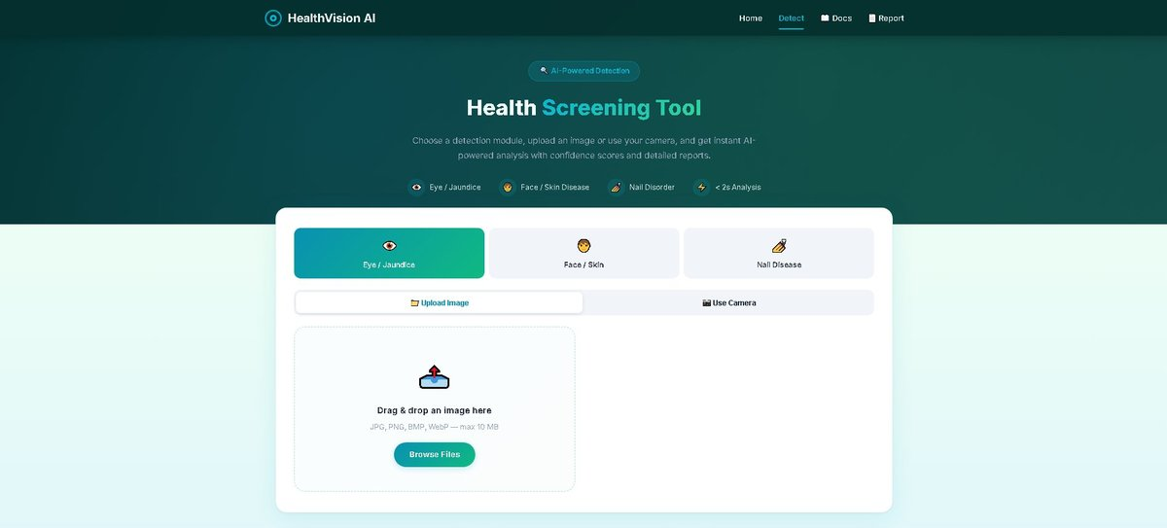
Figure 4.9: Health Screening Tool — Main Detection Interface with Module Selector
4.10.2 Core Capabilities
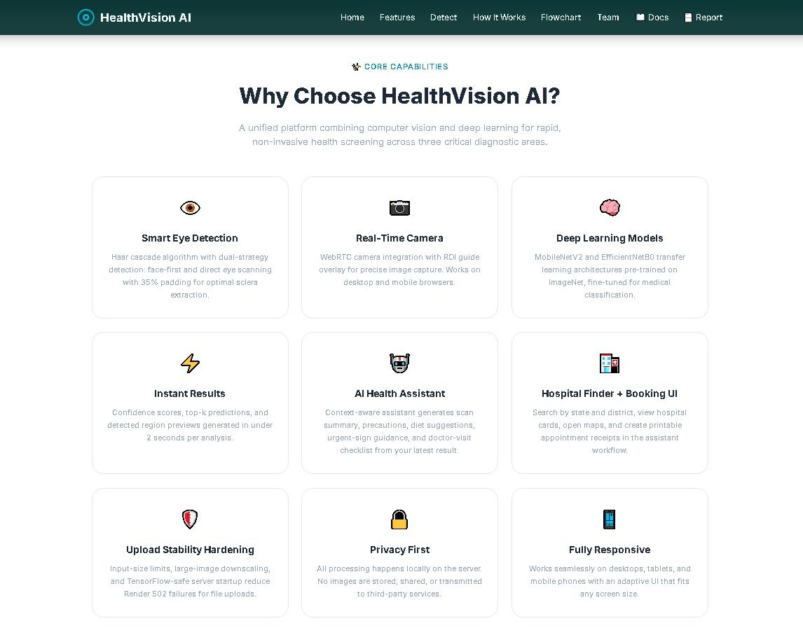
Figure 4.10: Core Capabilities Page — Platform Features Overview
4.10.3 Eye / Jaundice Detection Result

Figure 4.11: Eye/Jaundice Detection — Result with Sclera Crop, Confidence Score, and Disease Info
4.10.4 Face / Skin Disease Detection Result

Figure 4.12: Face/Skin Disease Detection — Top-3 Predictions with Confidence Bars

4.10.5 Nail Disease Detection Result

Figure 4.13: Nail Disease Detection — Result with Severity Indicator and Medical Info
4.10.6 Pipeline — How It Works
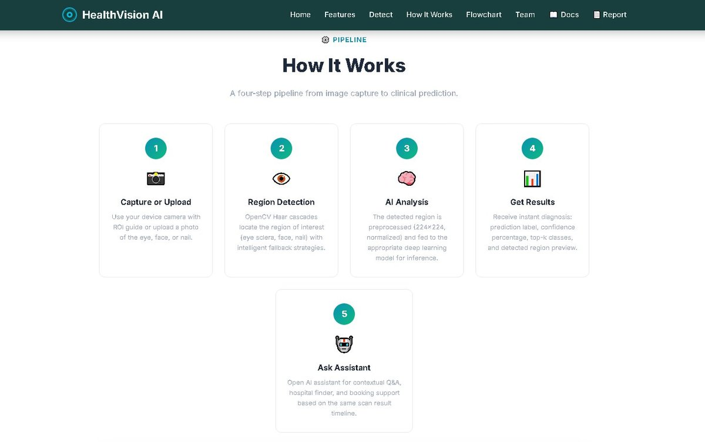
Figure 4.14: How It Works — 5-Step Pipeline from Capture to AI-Guided Follow-up

4.10.7 Technologies & Tools

Figure 4.16: Technologies & Tools Grid — Complete Tech Stack of HealthVision AI
4.10.8 AI Clinical Assistant
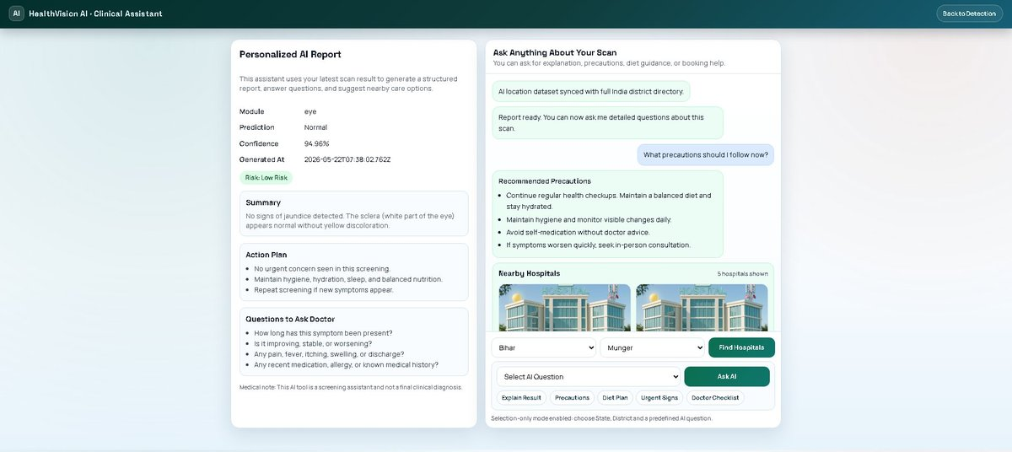
Figure 4.17: AI Clinical Assistant — Personalized Report, Chat, and Hospital Finder
4.10.9 Project Team
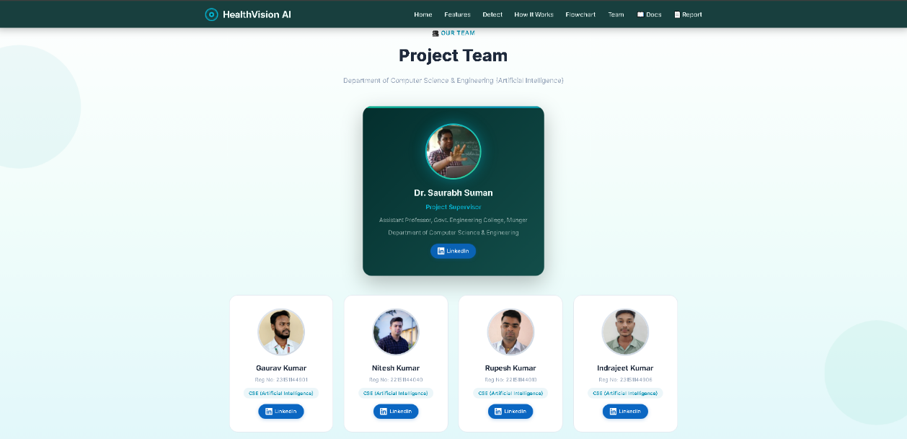
Figure 4.18: Project Team — Supervisor and Student Developers

CHAPTER 5

DISCUSSION OF RESULTS

5.1 Training Results & Accuracy
All three models were trained using the two-stage transfer learning strategy described in Chapter 4. The validation accuracy results are summarized below:
Model | Architecture | Val Accuracy | Train Images | Loss Function
Jaundice (Eye) | MobileNetV2 | 90.62% | 136 | Binary Cross-Entropy
Face (Skin) | EfficientNetB0 | 72.15% | 1,196 | Categorical Cross-Entropy
Nail Disease | MobileNetV2 | 85.71% | 933 | Categorical Cross-Entropy

Table 5.1: Model Training Results
Key Observations:
- The Jaundice model achieves the highest accuracy (90.62%) despite the smallest dataset (136 training images), demonstrating the effectiveness of transfer learning for binary classification tasks.
- The Face model has lower accuracy (72.15%) due to the 5-class complexity and visual similarity between conditions such as Acne and Rosacea, or Herpes and Eczema. Expanding the training dataset is expected to improve this.
- The Nail model achieves strong accuracy (85.71%) with three well-separated visual classes.
- All models benefit from the two-stage training with EarlyStopping and ReduceLROnPlateau callbacks that prevent overfitting.
Sample Test Results:
Test Case | Prediction | Confidence | Result
Jaundiced Eye Image | Jaundice | 82.01% | Correct
Normal Eye Image | Normal | 93.33% | Correct
Eczema Face Image | Eczema | 99.75% | Correct
Psoriasis Nail Image | Psoriasis | 65.09% | Correct
Healthy Nail Image | Healthy | 93.8% | Correct

5.2 Testing
Unit Testing
Test ID | Module | Test Case | Expected Result | Status
TC-01 | Eye | Upload valid eye image | Returns prediction JSON | PASS
TC-02 | Eye | Upload non-image file | Returns error message | PASS
TC-03 | Eye | No file uploaded | Returns "No file" error | PASS
TC-04 | Face | Upload face image | Returns top-3 predictions | PASS
TC-05 | Face | Upload corrupted image | Returns decode error | PASS
TC-06 | Nail | Upload nail image | Returns prediction + scores | PASS
TC-07 | Nail | Camera capture | Returns prediction | PASS
TC-08 | All | Invalid file extension | Returns invalid type error | PASS

Table 4.8: Unit Test Results
Integration Testing
Test ID | Description | Status
IT-01 | Frontend to Backend API communication via AJAX | PASS
IT-02 | Image upload + full preprocessing and inference pipeline | PASS
IT-03 | Camera capture + prediction flow on desktop and mobile | PASS
IT-04 | All three TensorFlow models loading at startup | PASS
IT-05 | Disease info database retrieval for all predicted classes | PASS
IT-06 | AI report generation from scan payload via /api/ai/report | PASS
IT-07 | Hospital finder and inline chat timeline rendering | PASS
IT-08 | Upload inference stability on Render cloud with large images | PASS

Table 4.9: Integration Test Results

5.3 Advantages & Limitations
Advantages
- Multi-Disease Detection: Three detection modules (Eye, Face, Nail) in a single unified platform — unique in the academic project space.
- Non-Invasive Screening: Enables jaundice screening without blood tests using only a smartphone camera.
- User-Friendly Interface: Modern, responsive design with intuitive UX for both upload and real-time camera capture.
- Intelligent Eye Detection: Multi-strategy Haar cascade pipeline (face→eye, direct eye, fallback) ensures robust sclera extraction.
- Image Enhancement Pipeline: Automatic denoising (bilateral filter) and contrast normalization (CLAHE) improve real-world accuracy.
- Comprehensive Disease Information: Severity levels, descriptions, causes, symptoms, and specialist recommendations for 25+ conditions.
- AI Health Assistant: Post-prediction guided Q&A, hospital finder, and appointment booking UI — first-of-its-kind in student projects.
- Privacy-First: All processing happens on-server; no images are stored or transmitted to third parties.
- Cloud Deployed: Accessible from any device via internet at https://healthvision-ai-1enh.onrender.com.
Limitations
- Not a Medical Diagnostic Tool: Provides preliminary screening assessments only; not a substitute for professional clinical diagnosis.
- Dataset Limitations: Training datasets are relatively small (especially jaundice: 136 images), limiting generalization to diverse populations.
- Face Model Accuracy: 72.15% validation accuracy for 5-class skin disease classification reflects the visual similarity between some conditions.
- Image Quality Dependency: Poor lighting, motion blur, or low-resolution images can significantly affect prediction accuracy.
- Internet Dependency: Requires internet connection for cloud-hosted deployment; offline operation not currently supported.
- No Patient History: Predictions are based solely on single images with no longitudinal tracking.

CHAPTER 6

CONCLUSION AND FUTURE WORK

6.1 Conclusion
HealthVision AI successfully demonstrates the practical application of Deep Learning and Computer Vision in healthcare screening. The system integrates three distinct AI-powered disease detection modules — Jaundice (Eye Sclera Analysis), Skin Disease (Facial Image Classification), and Nail Disease — into a single, accessible, and privacy-first web application.
Key achievements of this project include:
- Successful implementation of CNN-based medical image classification achieving validation accuracies of 90.62% (Jaundice), 72.15% (Face/Skin), and 85.71% (Nail) using two-stage transfer learning.
- A robust image preprocessing pipeline with Bilateral Filtering and CLAHE enhancement that improves model performance on real-world camera images.
- An intelligent multi-strategy eye detection pipeline using OpenCV Haar cascades with face→eye, direct eye, and full-image fallback strategies.
- A modern, fully responsive web interface supporting both image upload and WebRTC-based live camera capture with ROI guide overlay.
- An integrated AI Health Assistant workflow for report explanation, precautions, diet guidance, hospital finder, and appointment booking support.
- A comprehensive disease information database covering 25+ conditions with severity levels, descriptions, causes, symptoms, and specialist recommendations.
- Production-grade cloud deployment on Render with TensorFlow-safe Gunicorn startup, input-size guards, and upload stability hardening.
While HealthVision AI is not intended to replace professional medical diagnosis, it serves as a valuable preliminary screening tool that can encourage early health awareness and timely medical consultations. The project demonstrates the significant potential of AI in democratizing healthcare access, particularly in underserved communities across rural India.

6.2 Future Scope
The following enhancements are planned or proposed for future development:
- Expand Disease Classes: Add more skin conditions (melanoma, basal cell carcinoma), nail disorders (alopecia areata nail manifestation, clubbing), and eye diseases (cataracts, glaucoma screening).
- Larger and More Diverse Datasets: Collecting more training images across diverse skin tones, lighting conditions, and geographic populations will significantly improve accuracy and generalization.
- Real-Time Video Analysis: Implement continuous frame-by-frame analysis during live camera feed for smoother real-time detection.
- Mobile Application: Develop native Android and iOS applications using TensorFlow Lite for on-device inference without server dependency, enabling offline use in areas with poor connectivity.
- Patient History Tracking: Add user accounts to maintain screening history, track disease progression over time, and generate longitudinal health reports.
- Multi-Language Support: Add support for Hindi, Maithili, Bhojpuri, and other regional languages spoken in Bihar and across India for broader accessibility.
- Explainable AI (XAI): Integrate Grad-CAM or SHAP visualizations to highlight image regions that influenced predictions, increasing transparency and clinician trust.
- Doctor Consultation Integration: Connect with telemedicine platforms or electronic health record (EHR) systems for direct professional follow-up from the screening result.
- Cloud GPU Inference: Deploy on AWS/GCP/Azure with GPU instances for faster inference latency and scalability to high traffic.
- Wearable Device Integration: Explore integration with wearable health devices (smartwatches, continuous glucose monitors) for comprehensive health data analysis.

REFERENCES
[1] Esteva, A., Kuprel, B., Novoa, R. A., Ko, J., Swetter, S. M., Blau, H. M., & Thrun, S. (2017). "Dermatologist-level classification of skin cancer with deep neural networks." Nature, 542(7639), 115–118.
[2] Gulshan, V., Peng, L., Coram, M., Stumpe, M. C., Wu, D., Narayanaswamy, A., ... & Webster, D. R. (2016). "Development and Validation of a Deep Learning Algorithm for Detection of Diabetic Retinopathy in Retinal Fundus Photographs." JAMA, 316(22), 2402–2410.
[3] Sandler, M., Howard, A., Zhu, M., Zhmoginov, A., & Chen, L. C. (2018). "MobileNetV2: Inverted Residuals and Linear Bottlenecks." Proceedings of the IEEE Conference on Computer Vision and Pattern Recognition (CVPR), 4510–4520.
[4] Tan, M., & Le, Q. V. (2019). "EfficientNet: Rethinking Model Scaling for Convolutional Neural Networks." Proceedings of the International Conference on Machine Learning (ICML), 6105–6114.
[5] Viola, P., & Jones, M. (2001). "Rapid Object Detection using a Boosted Cascade of Simple Features." Proceedings of the IEEE Conference on Computer Vision and Pattern Recognition (CVPR), 511–518.
[6] Deng, J., Dong, W., Socher, R., Li, L. J., Li, K., & Fei-Fei, L. (2009). "ImageNet: A Large-Scale Hierarchical Image Database." CVPR 2009, 248–255.
[7] Rajpurkar, P., Irvin, J., Ball, R. L., Zhu, K., Yang, B., Mehta, H., ... & Lungren, M. P. (2017). "CheXNet: Radiologist-Level Pneumonia Detection on Chest X-Rays with Deep Learning." arXiv:1711.05225.
[8] TensorFlow Documentation (2024). TensorFlow: An Open Source Machine Learning Framework. https://www.tensorflow.org/
[9] Flask Documentation (2024). Flask: A Lightweight WSGI Web Application Framework. https://flask.palletsprojects.com/
[10] OpenCV Documentation (2024). OpenCV: Open Source Computer Vision Library. https://docs.opencv.org/
[11] Keras Applications Documentation (2024). Pre-trained Models — EfficientNet, MobileNetV2. https://keras.io/api/applications/
[12] GTS AI (2024). Jaundiced/Normal Eyes Dataset. https://gts.ai/dataset-download/jaundiced-normal-eyes-dataset/
[13] GTS AI (2024). Facial Skin Diseases Dataset. https://gts.ai/dataset-download/facial-skin-diseases-dataset/
[14] Rasanjana, J. (2024). Nail Disease Image Classification Dataset. Kaggle. https://www.kaggle.com/datasets/josephrasanjana/nail-disease-image-classification-dataset
[15] World Health Organization (2021). "Universal Health Coverage Fact Sheet." WHO. https://www.who.int/news-room/fact-sheets/detail/universal-health-coverage-(uhc)
[16] HealthVision AI GitHub Repository (2026). https://github.com/gauravssah/HealthVision-AI
[17] HealthVision AI Live Demo (2026). https://healthvision-ai-1enh.onrender.com

